Evidence Hash Values

Adief :
1: 95851d30dd9f5f54684fd93776e5593f7e80f5752cc1812ca2a0d290ee16dad4
2: c8119a0fcea5eaf2ee8251f9f8cef07f76779dc27175219bc63592299c26123f

Alysha:

95851d30dd9f5f54684fd93776e5593f7e80f5752cc1812ca2a0d290ee16dad4
c8119a0fcea5eaf2ee8251f9f8cef07f76779dc27175219bc63592299c26123f

Alawi:
1. 95851d30dd9f5f54684fd93776e5593f7e80f5752cc1812ca2a0d290ee16dad4,C:\Users\aa_al\OneDrive\Desktop\Evidence_01_Confidential_Logistics_Report.pdf.pdf

2.
c8119a0fcea5eaf2ee8251f9f8cef07f76779dc27175219bc63592299c26123f,C:\Users\aa_al\OneDrive\Desktop\Evidence_02_Drug_Seizure_Examination_Report.pdf

Hasya:
Evidence 1: 95851d30dd9f5f54684fd93776e5593f7e80f5752cc1812ca2a0d290ee16dad4 (SHA-256)
Evidence 2: c8119a0fcea5eaf2ee8251f9f8cef07f76779dc27175219bc63592299c26123f (SHA-256)
Abi:
e48db80af119b8572ee1c3948a9ae2aa,C:\Users\Admin\Desktop\Case\Working\Evidence_02_Drug_Seizure_Examination_Report.pdf
c563132286169bff5b11327f1a274d47,C:\Users\Admin\Desktop\Case\Working\Evidence_01_Confidential_Logistics_Report.pdf.pdf

Adief

/Producer (Meridian Logistics Services)
/Author (Operations Assurance Unit)
/ReviewerRef (bWVyaWRpYW50cmFjZTQ3)

bWVyaWRpYW50cmFjZTQ3 (base 64) = meridiantrace47

/Type /EmbeddedFile
/Names [(reviewer_note.txt)]

bWVyaWRpYW50cmFjZTQ3

PDF TO TEXT CONVERTER :

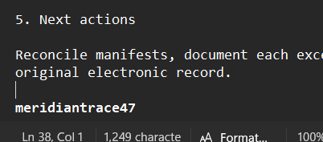

Alawi
/Title:Internal Operation Review (ML/OPS/2025/09-017 )
/Subjeck: Shipment record reconciliation, July-September 2025
/Keyword (Meridian Logistics; BL-047; NX-219; CR-081 )

Maigret

This one using meridiantrace47
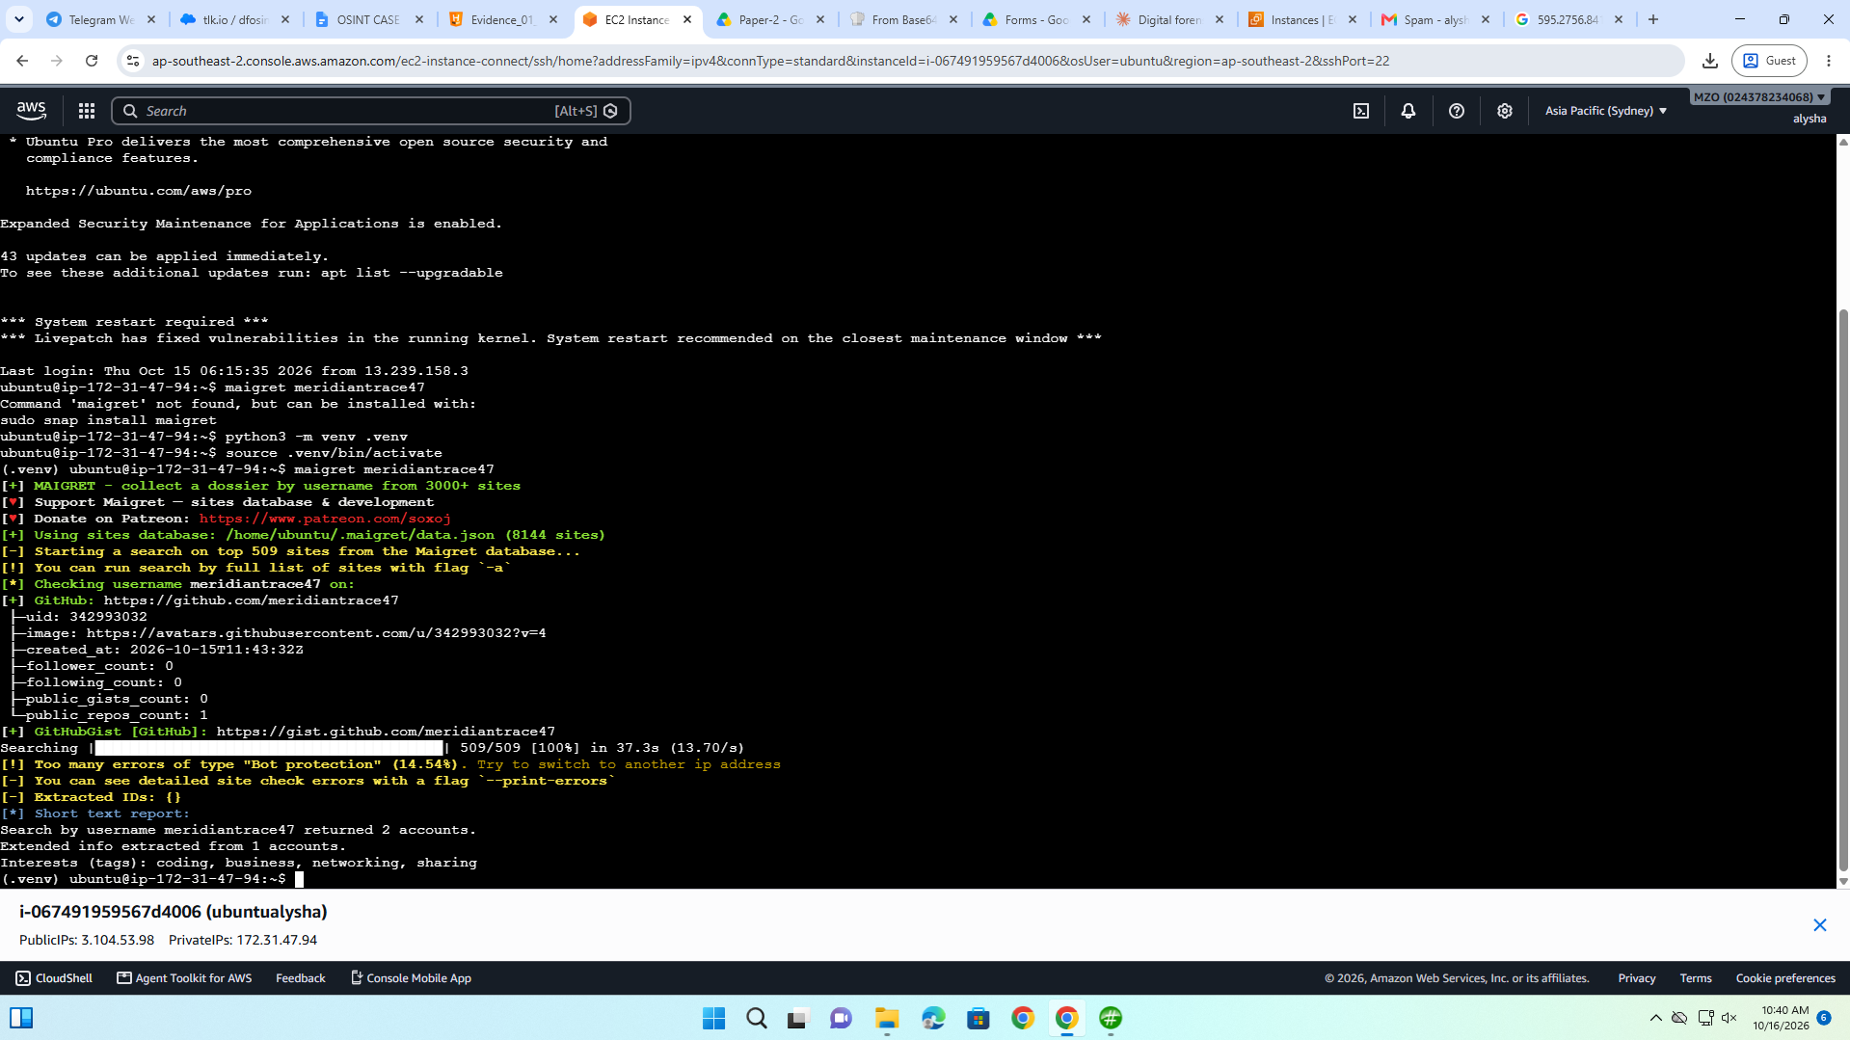
[+] GitHub: https://github.com/meridiantrace47
├─uid: 342993032
├─image: https://avatars.githubusercontent.com/u/342993032?v=4
├─created_at: 2026-10-15T11:43:32Z
├─follower_count: 0
├─following_count: 0
├─public_gists_count: 0
└─public_repos_count: 1
[+] GitHubGist [GitHub]: https://gist.github.com/meridiantrace47

meridian_trace47 (from github)

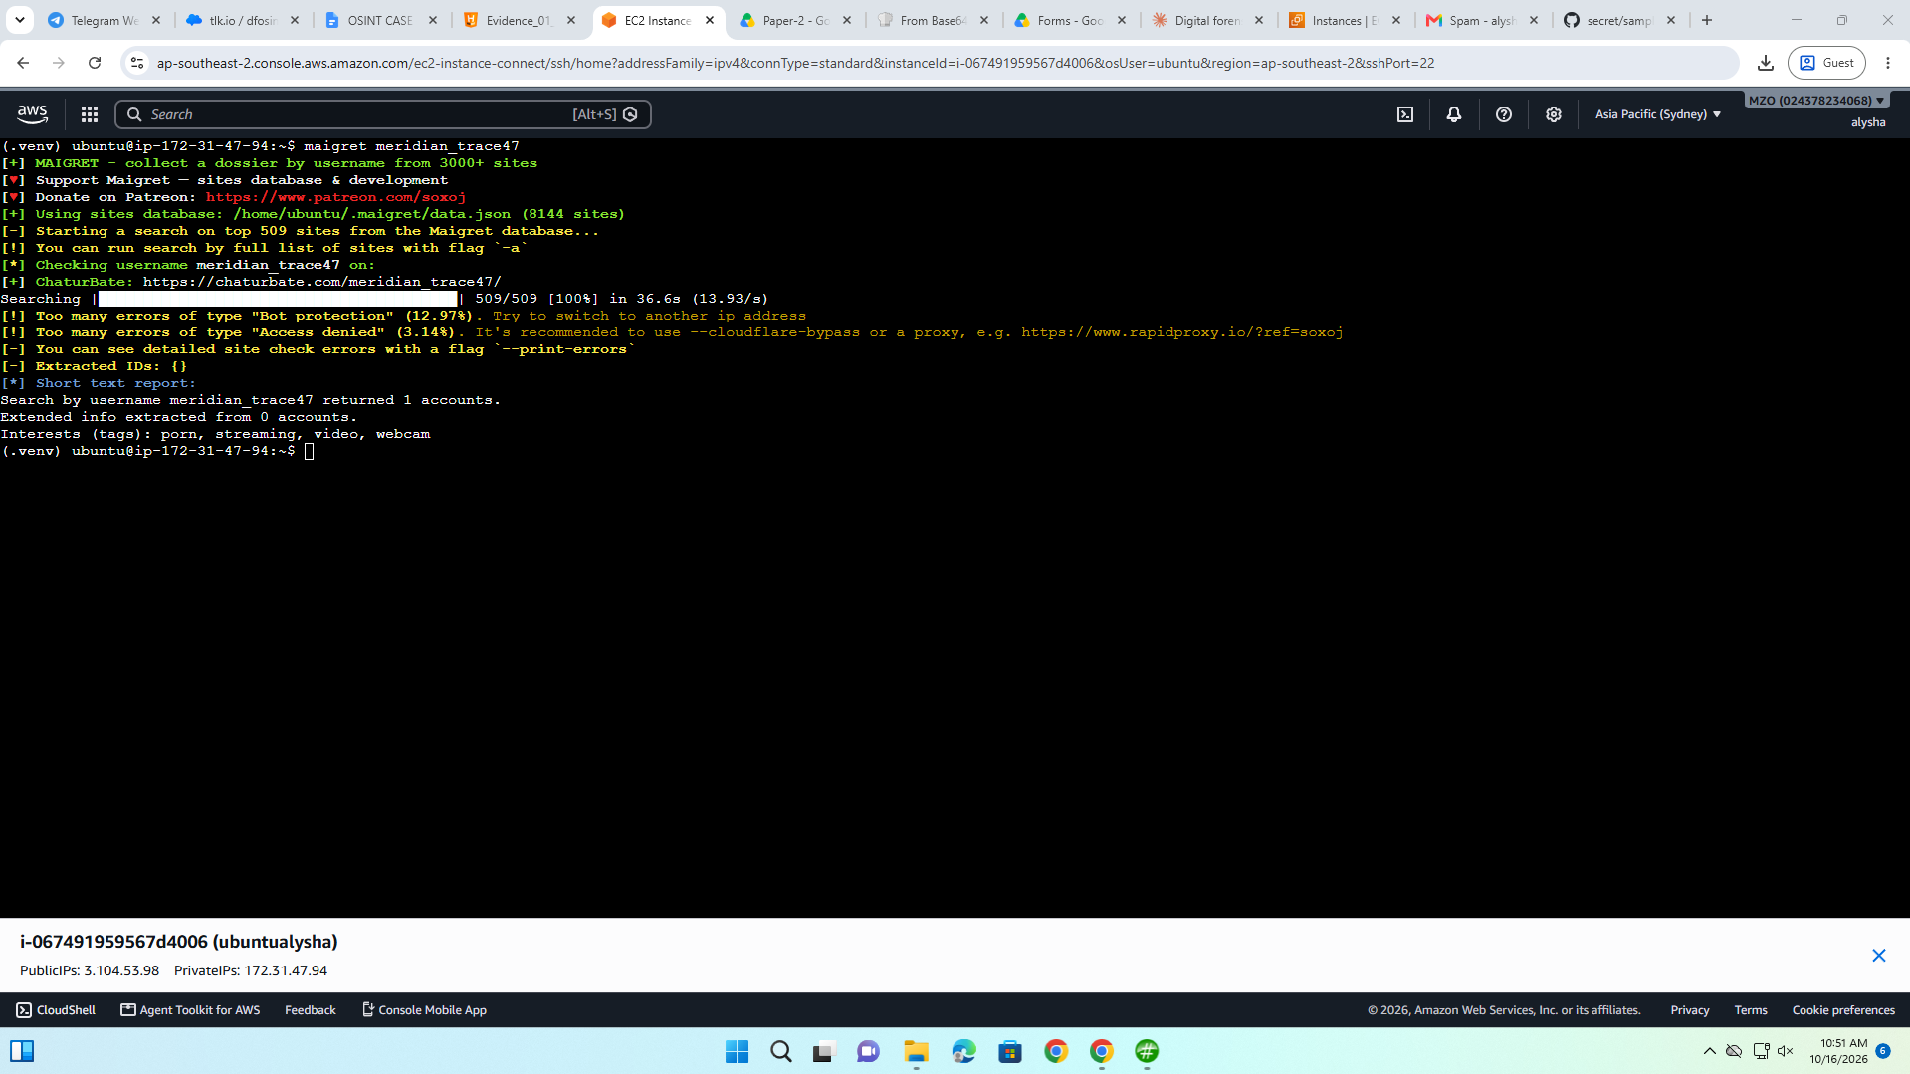

User-scanner for email meridiantrace47@gmail.com (no hits)
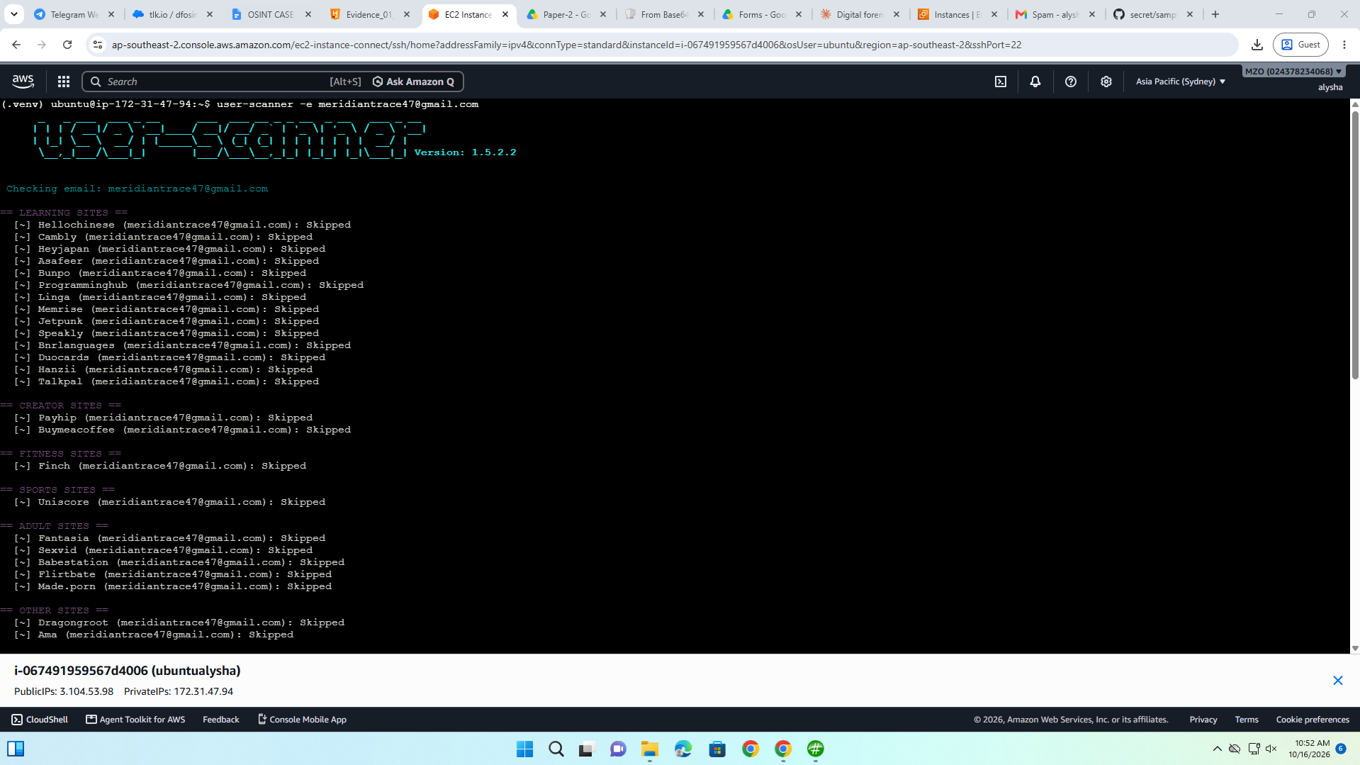
Sherlock

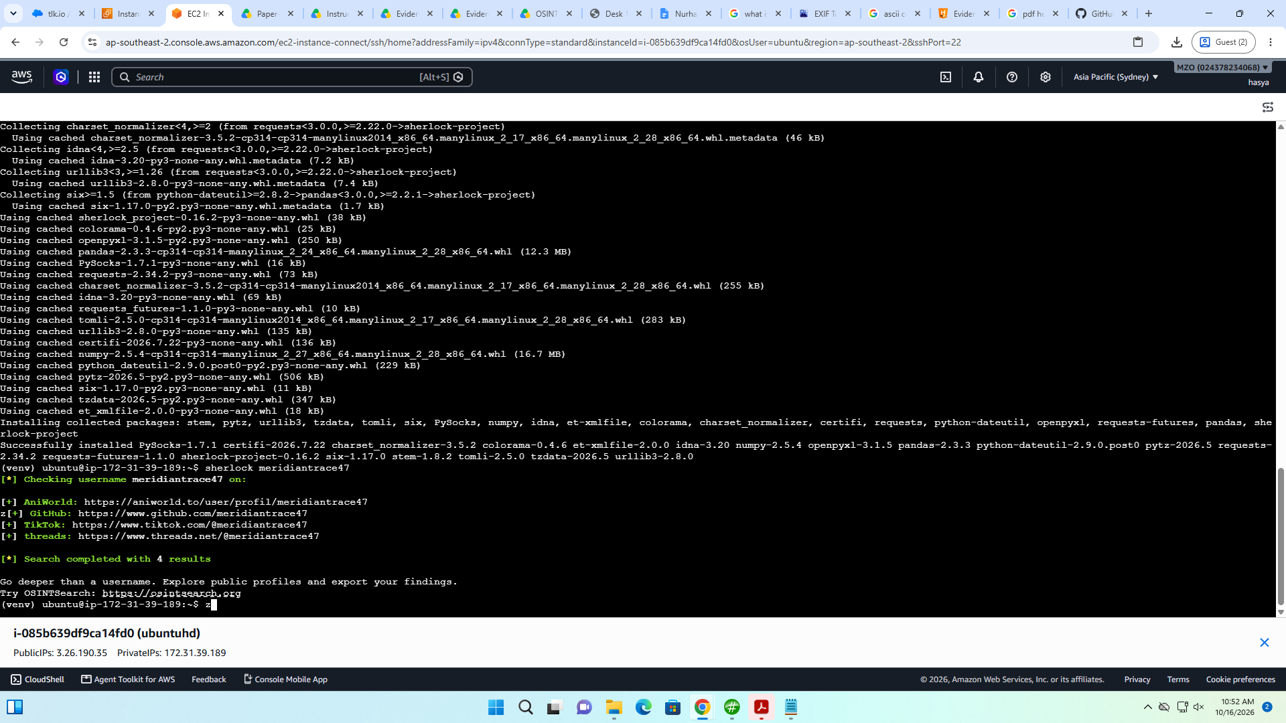

[*] Checking username meridiantrace47 on:

[+] AniWorld: https://aniworld.to/user/profil/meridiantrace47
[+] GitHub: https://www.github.com/meridiantrace47
[+] TikTok: https://www.tiktok.com/@meridiantrace47
[+] threads: https://www.threads.net/@meridiantrace47

[*] Search completed with 4 results

Developer: Daniel M.
GitHub Alias: meridian_trace47
Previous Alias: meridian47
Contact: meridiantrace47@gmail.com

BL-047 → 4 rows, status Seized
NX-219 → 8 rows, status Held for review

SEIZED SHIPMENT :

SHP-2025-007 | 2025-07-16 | BL-047 | Meridian Trading | Northstar Distribution | Warehouse A | Distribution Hub C | Office stationery | Methamphetamine | Stimulant | 6.4 | 11.4 | Seized | Yes | Yes | TXN-1047 | meridiantrace47 | Fictional laboratory/inspection finding; see separate case exhibit

SHP-2025-014 | 2025-08-13 | BL-047 | Meridian Trading | Northstar Distribution | Warehouse B | Distribution Hub C | Electronic accessories | Heroin | Opioid | 11.3 | 16.3 | Seized | Yes | Yes | TXN-1054 | meridiantrace47 | Fictional laboratory/inspection finding; see separate case exhibit

SHP-2025-022 | 2025-09-11 | BL-047 | Meridian Trading | Northstar Distribution | Warehouse B | Distribution Hub C | Machine spare parts | Cocaine | Stimulant | 2.9 | 7.9 | Seized | Yes | Yes | TXN-1062 | meridiantrace47 | Fictional laboratory/inspection finding; see separate case exhibit

SHP-2025-029 | 2025-09-18 | BL-047 | Meridian Trading | Northstar Distribution | Warehouse A | Distribution Hub C | Printed manuals | MDMA | Empathogen | 7.8 | 12.8 | Seized | Yes | Yes | TXN-1069 | meridiantrace47 | Fictional laboratory/inspection finding; see separate case exhibit

sample_shipments.csv
a3b4431eeb39a810b71e98bbc81ce3145c8f17cbd090c8860472b19904e7f056

Shipment | Date | Txn | Declared | Finding | Mass
SHP-2025-007 | 07-16 | TXN-1047 | Office stationery | Methamphetamine | 6.4 kg
SHP-2025-014 | 08-13 | TXN-1054 | Electronic accessories | Heroin | 11.3 kg
SHP-2025-022 | 09-11 | TXN-1062 | Machine spare parts | Cocaine | 2.9 kg
SHP-2025-029 | 09-18 | TXN-1069 | Printed manuals | MDMA | 7.8 kg

